**ECOMMERCE SALES DATA**

**DATA VALIDATION**

OBJECTIVE: Data Validation of Visuals in Power Bi Dashboard

of Ecommerce Sales.

**--Prerequisites and Data cleaning**

**USE** ecommerce;

**SELECT** * **FROM** ecommerce_data;

**DESC** ecommerce_data;

**-- Changing datatype for orderdate and ship date**

**SET** sql_safe_updates=0;

**UPDATE** ecommerce_data

**SET** order_date = date_format(str_to_date(order_date,'%d-%m-%Y'),'%Y-%m-%d');

**ALTER TABLE** ecommerce_data

**MODIFY** order_date DATE;

**UPDATE** ecommerce_data

**SET** ship_date = date_format(str_to_date(ship_date,'%d-%m-%Y'),'%Y-%m-%d');

**ALTER TABLE** ecommerce_data

**MODIFY** ship_date DATE;

**KPI**

**-- YTD Sales**

**SELECT** ROUND(SUM( sales_per_order) /1000000,2) **AS** YTD_Sales

**FROM** ecommerce_data

**WHERE** **YEAR**(order_date) = 2022;

Output:

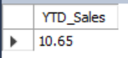

**--** **YTD Profit**

**SELECT** ROUND(SUM(profit_per_order ) /1000000,2) **AS** YTD_Sales

**FROM** ecommerce_data

**WHERE** **YEAR**(order_date) = 2022;

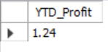Output:

**-- YTD Quantity Sold**

**SELECT** ROUND(SUM(order_quantity ) /1000,1) **AS** YTD_Sales

**FROM** ecommerce_data

**WHERE YEAR**(order_date) = 2022;

Output:



**-- YTD Profit Margin**

**SELECT** ROUND((SUM(profit_per_order ) / SUM( sales_per_order)) * 100,2) **AS** YTD_Profit_Margin

**FROM** ecommerce_data

**WHERE YEAR**(order_date) = 2022;

Output:

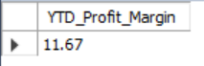

**MATRIX VISUAL**

**-- YTD Sales, PYTD Sales , YOY Sales by Product category**

**WITH** ct1 **AS** (

**SELECT** category_name **AS** product_category,

**ROUND**(SUM( sales_per_order) /1000000,4) **AS** YTD_Sales

**FROM** ecommerce_data Output:

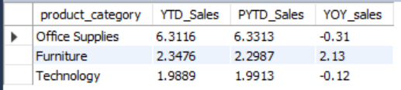 **WHERE** **YEAR**(order_date) = 2022

**GROUP BY** 1),

ct2 **AS** (

**SELECT** category_name **AS** product_category,

**ROUND**(**SUM**( sales_per_order) /1000000,4) **AS** PYTD_Sales

**FROM** ecommerce_data

**WHERE YEAR**(order_date) = 2021

**GROUP BY** 1

**ORDER BY** 2 DESC)

**SELECT** ct1.product_category, ct1.YTD_Sales,ct2.PYTD_Sales ,

**ROUND**(((ct1.YTD_Sales-ct2.PYTD_Sales) / ct2.PYTD_Sales )* 100,2) **AS** YOY_sales

**FROM** ct1,ct2

**WHERE** ct1.product_category=ct2.product_category

**GROUP BY** 1;

**BAR CHART**

**-- Top 5 Products by YTD Sales**

**SELECT** product_name, **ROUND**(**SUM**(sales_per_order)/1000,0) **AS** sales

**FROM** ecommerce_data

**WHERE YEAR**(order_date) = 2022

**GROUP BY** 1

**ORDER BY** 2 DESC

**LIMIT** 5;

Output:

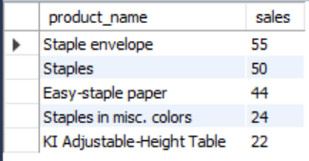

**-- Bottom 5 Products by YTD Sales**

**SELECT** * **FROM**(

**SELECT** product_name,**ROUND**(**SUM**(sales_per_order),0) AS sales

**FROM** ecommerce_data

**WHERE YEAR**(order_date) = 2022

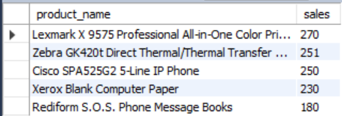**GROUP BY** 1 Output:

**ORDER BY** 2 ASC

**LIMIT** 5 ) **AS** bottom_sales

**ORDER BY** sales DESC;

**DONUT CHARTS**

**-- YTD Sales by region**

**SELECT** customer_region **AS** region,

**SUM**(sales_per_order) **AS** sales,

**ROUND**( **SUM**(sales_per_order)/ (**SELECT** **SUM**(sales_per_order) **FROM** ecommerce_data

**WHERE YEAR**(order_date) = 2022) *100,0) **AS** percent_total

**FROM** ecommerce_data

**WHERE YEAR**(order_date) = 2022

**GROUP BY** 1;

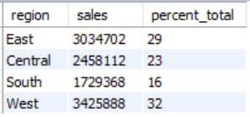Output:

**-- YTD Sales by shipping mode**

**SELECT** shipping_type **AS** mode, **SUM(**sales_per_order**) AS** sales**,**

**ROUND**( **SUM**(sales_per_order)/ (**SELECT** **SUM**(sales_per_order) **FROM** ecommerce_data

**WHERE YEAR**(order_date) = 2022) *100,0) **AS** percent_total

**FROM** ecommerce_data

**WHERE YEAR**(order_date) = 2022

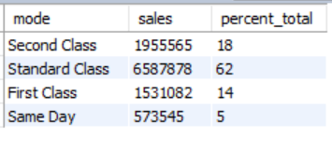 **GROUP BY** 1;

Output:

**MAP VISUAL**

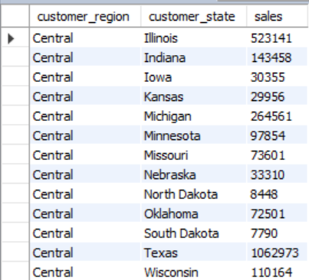

**-- YTD Sales by customer_state**

**SELECT** customer_region,customer_state,

**SUM**(sales_per_order) **AS** sales

**FROM** ecommerce_data

**WHERE YEAR**(order_date) = 2022

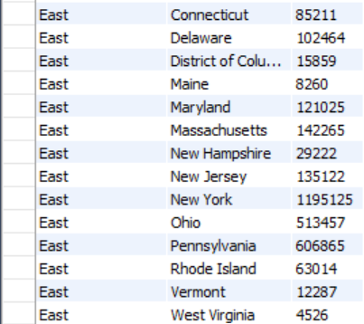 **GROUP BY** 1,2

**ORDER BY** 1;

Output:

